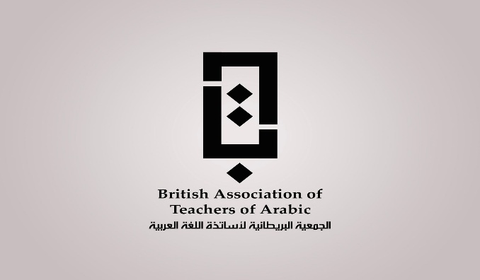

The 2026 BATA 6th Annual International Conference, 25 – 26 June, 2026

Please fill in the following submission form and return to: Bata_conference2026@outlook.com
Please submit your abstract and biography as indicated below.
Title: __________________________________________________________
Full name: ______________________________________________________
Affiliation/institution: _______________________________________________
Corresponding author’s email: _______________________________________
Participation: All participations are in-person

TITLE OF PAPER: _______________________________________________
ABSTRACT
An abstract is a summary of your research. It should state the problem, the objectives, the methodology used, and the major results and conclusions. It should be single-spaced in 12-point Times New Roman. Do not include bullets or lists in the abstract. The abstracts will be peer-reviewed and authors will be informed about the outcome of their submission via email. Please do not exceed the word count for the abstract (250 words). The abstract should be submitted in a MS Word document format.
Keywords:
Indicate the relevant Theme: Please select ONE theme only and delete irrelevant themes.

- Teaching Arabic and Culture
- Arabic Translation
- Arabic Literature and Literary Criticism
- Arabic Linguistics

ABSTRACTS:

Insert your abstract in the box below (word count should not exceed 250 words).
Max. 250 words (please do not exceed)

Biography
Please send your biography together with the abstract using the following format:
- Full name
- Position /department/organization/country
- Contact information (address, contact/mobile number, email address, Twitter account)
Insert your Biography below: (word count should not exceed 100 words)

Please do not send your CV.

Max. 100 words (please do not exceed)

Once you prepared your abstract and biography according to the above guidelines, please submit your abstract to: Bata_conference2026@outlook.com

